http://www.dotnettricks.com/learn/oops/object-oriented-programming-concepts:
Object-Oriented Programming Concepts (www.dotnettricks.com)
Author : Shailendra Chauhan
Posted On : 15 Feb 2011
Updated On : 10 Jul 2012

Server Side Model Validation in MVC Razor
Server side validations are required for ensuring that the received data is correct and valid. If the received data is valid then we do the further processing with the data. Server side validations are very important before playing with sensitive information of a user.
Server-side validation must be done whether we validate the received data on the client side. User could disable script in his browser or do something else to bypass client-side validation. In this case server-side validation must required to protect our data from dirty input.

Server-side model validation technique
In MVC Razor, we can validate a model server side by below two ways:
- Explicit Model Validation
- Model Validation with Data Annotations

Explicit Model Validation
Suppose, you want to validate the registration process of a user for which the Registration model and view are defined as below:

RegistrationModel.cs
- public class RegistrationModel
- {
- public string UserName { get; set; }
- public string Password { get; set; }
- public string ConfirmPassword { get; set; }
- public Country Country { get; set; }
- public City City { get; set; }
- public string Address { get; set; }
- public string MobileNo { get; set; }
- public bool TermsAccepted { get; set; }
- }

- public class Country
- {
- public int? ID { get; set; }
- public string Name { get; set; }
- }

- public class City
- {
- public int? ID { get; set; }
- public string Name { get; set; }
- public int? Country { get; set; }
- }

ExplicitServer.cshtml
- @model Mvc4_Client_ServerSideValidation.Models.RegistrationModel
- @{
- ViewBag.Title = "Explicit Server Side Validation";
- }
- <script src="../../Scripts/jquery-1.7.1.min.js" type="text/javascript"></script>
- <script type="text/jscript">
- $(function () {
- $('#Country_ID').change(function () {
- var id = $("#Country_ID :selected").val();
- if (id != "") {
- $.ajax({
- type: "GET",
- contentType: "application/json; charset=utf-8",
- url: '@Url.Action("CityList", "Home")',
- data: { "mCountry": id },
- dataType: "json",
- success: function (data) {
- var items = "";
- $.each(data, function (i, city) {
- items += "<option value='" + city.Value + "'>" + city.Text + "</option>";
- });
- $('#City_ID').html(items);
- },
- error: function (result) {
- alert('Service call failed: ' + result.status + ' Type :' + result.statusText);
- }
- });
- }
- else
- {
- var items = '<option value="">Select</option>';
- $('#City_ID').html(items);
- } });
- });
- </script>
- <h2>Explicit Server Side Validation</h2> @using (Html.BeginForm())
- {
- <fieldset>
- <ol>
- <li>
- @Html.LabelFor(m => m.UserName)
- @Html.TextBoxFor(m => m.UserName, new { maxlength = 50 })
- @Html.ValidationMessageFor(m => m.UserName)
- </li>
- <li>
- @Html.LabelFor(m => m.Password)
- @Html.PasswordFor(m => m.Password, new { maxlength = 50, value = ViewBag.Selpwd })
- @Html.ValidationMessageFor(m => m.Password)
- </li>
- <li>
- @Html.LabelFor(m => m.ConfirmPassword)
- @Html.PasswordFor(m => m.ConfirmPassword, new { maxlength = 50, value = ViewBag.Selconfirmpwd })
- @Html.ValidationMessageFor(m => m.ConfirmPassword)
- </li>
- <li>
- @Html.LabelFor(m => m.Country)
- @Html.DropDownListFor(m => m.Country.ID, new SelectList(ViewBag.Country, "ID", "Name"), new { style = "width:310px" })
- @Html.ValidationMessageFor(m => m.Country)
- </li>
- <li>
- @Html.LabelFor(m => m.City)
- @Html.DropDownListFor(m => m.City.ID, new SelectList(ViewBag.City, "ID", "Name"), new { style = "width:310px" })
- @Html.ValidationMessageFor(m => m.City)
- </li>
- <li>
- @Html.LabelFor(m => m.Address)
- @Html.TextAreaFor(m => m.Address, new { maxlength = 200 })
- @Html.ValidationMessageFor(m => m.Address)
- </li>
- <li>
- @Html.LabelFor(m => m.MobileNo)
- @Html.TextBoxFor(m => m.MobileNo, new { maxlength = 10 })
- @Html.ValidationMessageFor(m => m.MobileNo)
- </li>
- <li>
- @Html.CheckBoxFor(m => m.TermsAccepted) I accept the terms & conditions
- @Html.ValidationMessageFor(m => m.TermsAccepted)
- </li>
- </ol>
- <input type="submit" value="Submit" />
- </fieldset>
- }
Now let's see how we validate the model explicitly?. To validate a model explicitly we need to validate received data with in the action method like as:
- [HttpPost]
- public ActionResult ExplicitServer(RegistrationModel mRegister)
- {
- //Write custom logic to validate RegistrationModel
- if (string.IsNullOrEmpty(mRegister.UserName))
- {
- ModelState.AddModelError("UserName", "Please enter your name");
- }
- if (!string.IsNullOrEmpty(mRegister.UserName))
- {
- Regex emailRegex = new Regex(".+@.+\\..+");
- if (!emailRegex.IsMatch(mRegister.UserName))
- ModelState.AddModelError("UserName", "Please enter correct email address");
- }
- if (string.IsNullOrEmpty(mRegister.Password))
- {
- ModelState.AddModelError("Password", "Please enter password");
- }
- if (string.IsNullOrEmpty(mRegister.ConfirmPassword))
- {
- ModelState.AddModelError("ConfirmPassword", "Please enter confirm password");
- }
- if (string.IsNullOrEmpty(mRegister.ConfirmPassword) && string.IsNullOrEmpty(mRegister.ConfirmPassword))
- {
- if (mRegister.ConfirmPassword != mRegister.Password)
- ModelState.AddModelError("ConfirmPassword", "Confirm password doesn't match");
- }
- if (mRegister.Country.ID == null || mRegister.Country.ID == 0)
- {
- ModelState.AddModelError("Country", "Please select Country");
- }
- if (mRegister.City.ID == null || mRegister.City.ID == 0)
- {
- ModelState.AddModelError("City", "Please select City");
- }
- if (string.IsNullOrEmpty(mRegister.Address))
- {
- ModelState.AddModelError("Address", "Please enter your address");
- }
- if (string.IsNullOrEmpty(mRegister.MobileNo))
- {
- ModelState.AddModelError("MobileNo", "Please enter your mobile no");
- }
- if (!mRegister.TermsAccepted)
- {
- ModelState.AddModelError("TermsAccepted", "You must accept the terms");
- }
- if (ModelState.IsValid)
- {
- return View("Completed");
- }
- else
- {
- ViewBag.Selpwd = mRegister.Password;
- ViewBag.Selconfirmpwd = mRegister.ConfirmPassword;
- BindCountry();

- if (mRegister.Country != null)
- BindCity(mRegister.Country.ID);
- else BindCity(null);

- return View();
- }
- }

How it works...
Afer running the project and navigating to ExplicitServer page you will get the below page. When you press the submit button on this page then it will post the data to the server and the code written with in ExplicitServer action will validate the input data. If input data is not valid then add error to model state by using method AddModelError() as shown above.
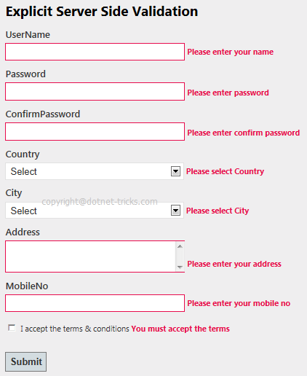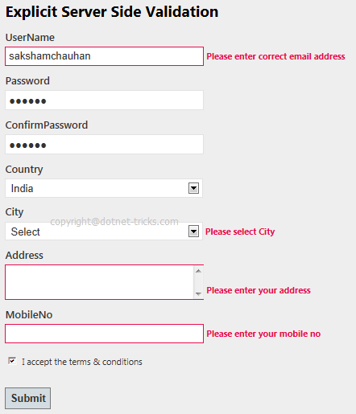
When all the validation will be passed then ModelState.IsValid returns true and you will be shown Completed view as shown in fig.
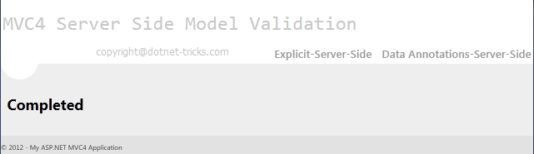

Model Validation with Data Annotations
The another and best way to validate a model by using Data Annotations. Data Annotations was introduced with .Net 3.5 SP1. It has a set of attributes and classes defined in the System.ComponentModel.DataAnnotations assembly. Data Annotations allow us to decorate model classes with metadata. This metadata describes a set of rules that are used to validate a property. For more help refer the article MVC Data Annotation.
In RegistrationModel.cs, I have defined one more model class RegistrationMetaModel by using data annotation and for which the view is defined as below:

RegistrationModel.cs
- public class RegistrationMetaModel
- {
- [Required(ErrorMessage = "Please Enter Email Address")]
- [Display(Name = "UserName (Email Address)")]
- [RegularExpression(".+@.+\\..+", ErrorMessage = "Please Enter Correct Email Address")]
- public string UserName { get; set; }

- [Required(ErrorMessage = "Please Enter Password")]
- [StringLength(50, ErrorMessage = "The {0} must be at least {2} characters long.", MinimumLength = 6)]
- [DataType(DataType.Password)]
- [Display(Name = "Password")]
- public string Password { get; set; }

- [Required(ErrorMessage = "Please Enter Confirm Password")]
- [StringLength(50, ErrorMessage = "The {0} must be at least {2} characters long.", MinimumLength = 6)]
- [DataType(DataType.Password)]
- [Display(Name = "Confirm password")]
- [Compare("Password", ErrorMessage = "The password and confirmation password do not match.")]
- public string ConfirmPassword { get; set; }

- [Display(Name = "Country")] [ValidCountryAttribute(ErrorMessage = "Please Select Country")]
- public Country Country { get; set; }

- [Display(Name = "City")]
- [ValidCityAttribute(ErrorMessage = "Please Select City")]
- public City City { get; set; }

- [Required(ErrorMessage = "Please Enter Address")]
- [Display(Name = "Address")]
- [MaxLength(200)]
- public string Address { get; set; }

- [Required(ErrorMessage = "Please Enter Mobile No")]
- [Display(Name = "Mobile")]
- [StringLength(10, ErrorMessage = "The Mobile must contains 10 characters", MinimumLength = 10)]
- public string MobileNo { get; set; }

- [MustBeTrue(ErrorMessage = "Please Accept the Terms & Conditions")]
- public bool TermsAccepted { get; set; }
- }

- public class MustBeTrueAttribute : ValidationAttribute
- {
- public override bool IsValid(object value)
- {
- return value is bool && (bool)value;
- }
- }
- public class ValidCountryAttribute : ValidationAttribute
- {
- public override bool IsValid(object value)
- {
- if (((Country)value).ID == null || ((Country)value).ID == 0)
- return false;
- else
- return true;
- }
- }
- public class ValidCityAttribute : ValidationAttribute
- {
- public override bool IsValid(object value)
- {
- if (((City)value).ID == null || ((City)value).ID == 0)
- return false;
- else
- return true;
- }
- }

ServerMeta.cshtml
- @model Mvc4_Model_ServerSideValidation.Models.RegistrationMetaModel
- @{
- ViewBag.Title = "Server Side Validation by Specifying Validation Rules Using Metadata";
- }
- <script src="../../Scripts/jquery-1.7.1.min.js" type="text/javascript"></script>
- <script type="text/jscript">
- $(function ()
- {
- $('#Country_ID').change(function ()
- {
- var id = $("#Country_ID :selected").val();
- if (id != "")
- {
- $.ajax({
- type: "GET",
- contentType: "application/json; charset=utf-8",
- url: '@Url.Action("CityList", "Home")',
- data: { "mCountry": id },
- dataType: "json",
- beforeSend: function () {
- },
- success: function (data) {
- var items = "";
- $.each(data, function (i, city) {
- items += "<option value='" + city.Value + "'>" + city.Text + "</option>";
- });
- $('#City_ID').html(items);
- },
- error: function (result) {
- alert('Service call failed: ' + result.status + ' Type :' + result.statusText);
- }
- });
- }
- else {
- var items = '<option value="">Select</option>';
- $('#City_ID').html(items);
- }
- });
- });
- </script>
- <h2>Server Side Validation by Specifying Validation Rules Using Metadata</h2>
- @using (Html.BeginForm())
- {
- <fieldset>
- <ol>
- <li>
- @Html.LabelFor(m => m.UserName)
- @Html.TextBoxFor(m => m.UserName, new { maxlength = 50 })
- @Html.ValidationMessageFor(m => m.UserName)
- </li>
- <li>
- @Html.LabelFor(m => m.Password)
- @Html.PasswordFor(m => m.Password, new { maxlength = 50, value = ViewBag.Selpwd })
- @Html.ValidationMessageFor(m => m.Password)
- </li>
- <li>
- @Html.LabelFor(m => m.ConfirmPassword)
- @Html.PasswordFor(m => m.ConfirmPassword, new { maxlength = 50, value = ViewBag.Selconfirmpwd })
- @Html.ValidationMessageFor(m => m.ConfirmPassword)
- </li>
- <li>
- @Html.LabelFor(m => m.Country)
- @Html.DropDownListFor(m => m.Country.ID, new SelectList(ViewBag.Country, "ID", "Name", ViewBag.SelCountry), new { style = "width:310px" })
- @Html.ValidationMessageFor(m => m.Country)
- </li>
- <li>
- @Html.LabelFor(m => m.City)
- @Html.DropDownListFor(m => m.City.ID, new SelectList(ViewBag.City, "ID", "Name", ViewBag.SelCity), new { style = "width:310px" })
- @Html.ValidationMessageFor(m => m.City)
- </li>
- <li>
- @Html.LabelFor(m => m.Address)
- @Html.TextAreaFor(m => m.Address, new { maxlength =200 })
- @Html.ValidationMessageFor(m => m.Address)
- </li>
- <li>
- @Html.LabelFor(m => m.MobileNo)
- @Html.TextBoxFor(m => m.MobileNo ,new { maxlength = 10 })
- @Html.ValidationMessageFor(m => m.MobileNo)
- </li>
- <li>
- @Html.CheckBoxFor(m => m.TermsAccepted) I accept the terms & conditions
- @Html.ValidationMessageFor(m => m.TermsAccepted)
- </li>
- </ol>
- <input type="submit" value="Submit" />
- </fieldset>
- }
Now let's see how we validate the model using data annotation?. To validate a model explicitly we need to validate received data with in the action method by checking ModelState.IsValid property. If it is false then error message will be shown automatically against each propety of model as shown below in fig.
- [HttpPost]
- public ActionResult ServerMeta(RegistrationMetaModel mRegister)
- {
- if (ModelState.IsValid)
- {
- return View("Completed");
- }
- else
- {
- ViewBag.Selpwd = mRegister.Password;
- ViewBag.Selconfirmpwd = mRegister.ConfirmPassword;
- BindCountry();

- if (mRegister.Country != null)
- BindCity(mRegister.Country.ID);
- else
- BindCity(null);
- return View();
- }
- }

How it works...
After running the project and navigating to Data Annotation-Server-Side page you will get the below page. When you press the submit button on this page then it will post the data to the server and the code written with in ServerMeta action will validate the input data by checking ModelState.IsValid property. If input data is not valid then ModelState.IsValid will return false and shown error as shown below.
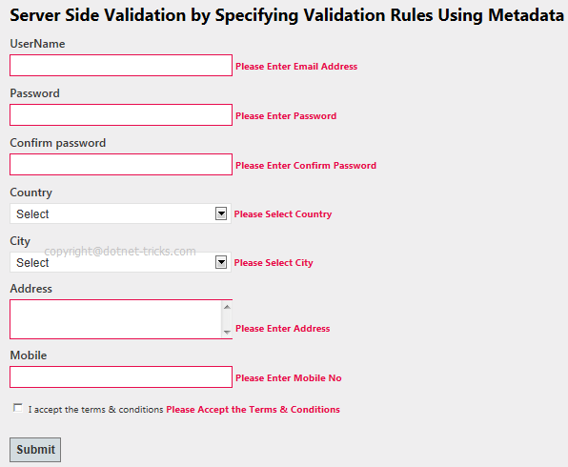&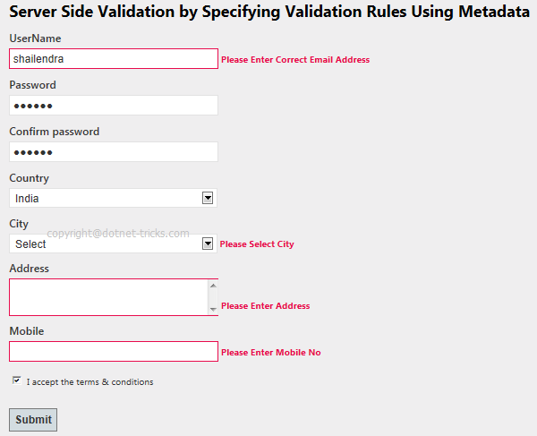
When all the validation will be passed then ModelState.IsValid returns true and you will be shown Completed view as shown in fig.

Difference Between Razor View Engine and ASPX View Engine
View Engine is responsible for rendering the view into html form to the browser. By default, Asp.net MVC support Web Form(ASPX) and Razor View Engine. There are many third party view engines (like Spark, Nhaml etc.) that are also available for Asp.net MVC. Now, Asp.net MVC is open source and can work with other third party view engines like Spark, Nhaml. In this article, I would like to expose the difference between Razor & Web Form View Engine.
Razor View Engine VS Web Form(ASPX) View Engine
Razor View Engine | Web Form View Engine
Razor Engine is an advanced view engine that was introduced with MVC3. This is not a new language but it is a new markup syntax. | Web Form Engine is the default view engine for the Asp.net MVC that is included with Asp.net MVC from the beginning.
The namespace for Razor Engine is System.Web.Razor. | The namespace for Webform Engine is System.Web.Mvc.WebFormViewEngine.
The file extensions used with Razor Engine are different from Web Form Engine. It has .cshtml (Razor with C#) or .vbhtml (Razor with VB) extension for views, partial views, editor templates and for layout pages. | The file extensions used with Web Form Engine are also like Asp.net Web Forms. It has .aspx extension for views, .ascx extension for partial views & editor templates and .master extension for layout/master pages.
Razor has new and advance syntax that are compact, expressive and reduces typing. | Web Form Engine has the same syntax like Asp.net Web Forms uses for .aspx pages.
Razor syntax are easy to learn and much clean than Web Form syntax. Razor uses @ symbol to make the code like as:  - @Html.ActionLink("SignUp", "SignUp") | Web Form syntax are borrowed from Asp.net Web Forms syntax that are mixed with html and sometimes make a view messy. Webform uses <% and %> delimiters to make the code like as:  - <%: Html.ActionLink("SignUp", "SignUp") %>
By default, Razor Engine prevents XSS attacks(Cross-Site Scripting Attacks) means it encodes the script or html tags like <,> before rendering to view. | Web Form Engine does not prevent XSS attacks means any script saved in the database will be fired while rendering the page
Razor Engine is little bit slow as compared to Webform Engine. | Web Form Engine is faster than Razor Engine.
Razor Engine, doesn't support design mode in visual studio means you cannot see your page look and feel. | Web Form engine support design mode in visual studio means you can see your page look and feel without running the application.
Razor Engine support TDD (Test Driven Development) since it is not depend on System.Web.UI.Page class. | Web Form Engine doesn't support TDD (Test Driven Development) since it depend on System.Web.UI.Page class which makes the testing complex.

